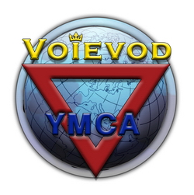
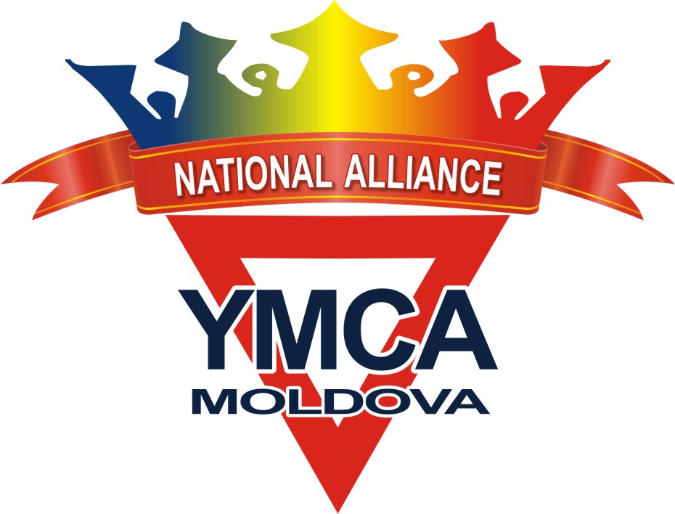
6th European YMCA-VOIEVOD
Championship & YMCA-Festival

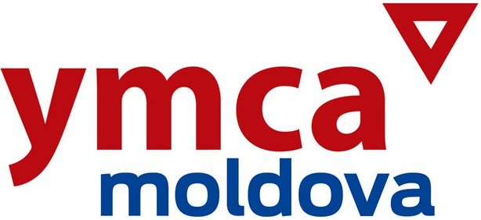
Moldova 2017

ENTRY FORM word.doc
Please send the by e-mail to the following address: ymcamoldova-alliance@mail.ru

COUNTRY
Team/Club/School
Postal address
Phone
Fax
e-mail
Homepage

Coach(es)
Head of Team

✴ Traditional Forms (individual)
Individual | No | NAME | NAT | M | F | Year of birth | KUP | DAN
 | 00 | Leahovcenco Alexandr | MOL | M | -- | 1988 | 1 k | --
 | 01
 | 02
 | 03
 | 04
 | 05

✴ Sparring – VOIEVOD style (individual)
Individual | No | NAME | NAT | M | F | Year of birth | KUP | DAN | Weight KG
 | 00 | Leahovcenco Alexandr | MOL | M | -- | 1988 | 1 k | -- | 70 kg
 | 01
 | 02
 | 03
 | 04
 | 05

✴ Sparring – TAEKWONDO style (individual)
Individual | No | NAME | NAT | M | F | Year of birth | KUP | DAN | Weight KG
 | 00 | Leahovcenco Alexandr | MOL | M | -- | 1988 | 1 k | -- | 70 kg
 | 01
 | 02
 | 03
 | 04
 | 05

✴ Synchronized Forms (team-fight)
TEAM | No | NAME | NAT | M | F | Year of birth | KUP | DAN
0 | 01 | Leahovcenco Alexandr | MOL | M | -- | 1988 | 1 k | --
 | 02 | Cislari Igor | MOL | M | -- | 1987 | 2 k | --

✴ Synchronized Forms (team-fight)
TEAM | No | NAME | NAT | M | F | Year of birth | KUP | DAN
1 | 01
 | 02

TEAM | No | NAME | NAT | M | F | Year of birth | KUP | DAN
1 | 01
 | 02
 | 03

TEAM | No | NAME | NAT | M | F | Year of birth | KUP | DAN
1 | 01
 | 02
 | 03
 | 04

TEAM | No | NAME | NAT | M | F | Year of birth | KUP | DAN
1 | 01
 | 02
 | 03
 | 04
 | 05

TEAM | No | NAME | NAT | M | F | Year of birth | KUP | DAN
1 | 01
 | 02
 | 03
 | 04
 | 05
 | 06

✴ Double Match (team-fight)
TEAM | No | NAME | NAT | M | F | Year of birth | KUP | DAN | Weight KG
0 | 01 | Lambant Stanislav | MOL | M | -- | 1986 | -- | 1 D | 72 kg
 | 02 | Osipov Nichita | MOL | M | -- | 1986 | -- | 1 D | 74 kg

✴ Double Match – VOIEVOD style (team-fight)
TEAM | No | NAME | NAT | M | F | Year of birth | KUP | DAN | Weight KG
1 | 01
 | 02

✴ Double Match – TAEKWONDO style (team-fight)
TEAM | No | NAME | NAT | M | F | Year of birth | KUP | DAN | Weight KG
1 | 01
 | 02

✴ Demonstration Show Teams
TEAM | No | NAME | NAT | M | F | Year of birth | KUP | DAN
0 | 00 | Lambant Stanislav | MOL | M | -- | 1986 | -- | 1 D
1 | 01
 | 02
 | 03
 | 04
 | 05
 | 06
 | 07
 | 08
 | 09
 | 10

