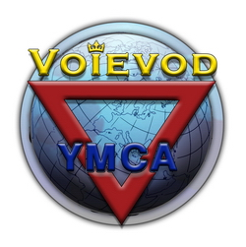
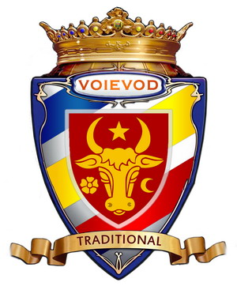
VOIEVOD MOLDOVA

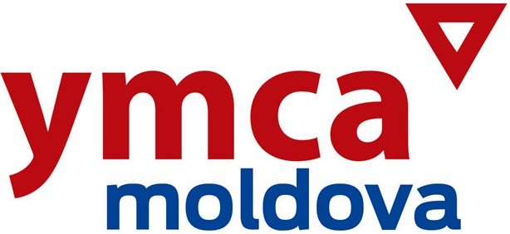

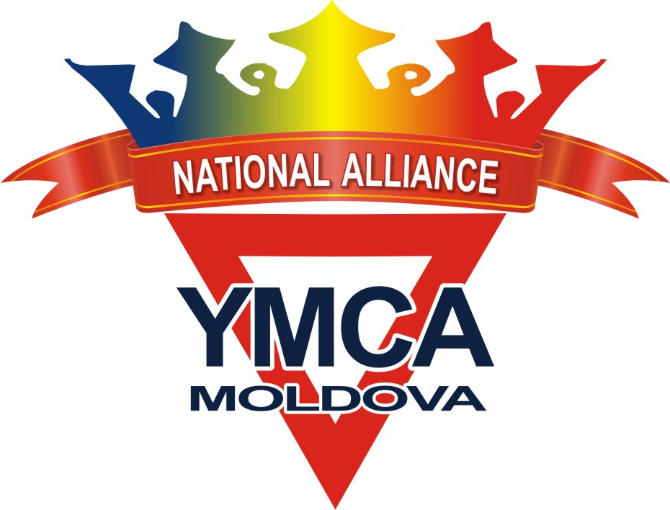

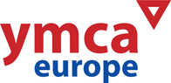

6th European YMCA-VOIEVOD
Championship & YMCA-Festival
of Moldova 2017

PROMOTER: The National Alliance YMCA Moldova www.facebook.com/ymcamoldova/

ORGANIZER: YMCA-VOIEVOD MOLDOVA www.voievod.org

PLACE: Moldova, Chisinau

DATE: April 08th – 09th 2017

PARTICIPANTS:
National and International open for all federations, clubs and all organizations of YMCA!
All competitors are considered to participate at their own risk.
Organizers assume no responsibility for any damages, injuries or losses.
Teams from foreign countries have to bring all necessary documents for a possible medical treatment in Moldova.

CATEGORIES: All belts / competitors of all ages kids, juniors and seniors / male and female

EVENTS: Open for all competitors of all styles of Martial Arts and all members of YMCA!
Saturday, April 08th - YMCA-VOIEVODChampionship | Sunday, April 09th - YMCA-Festival
1. Traditional Forms  2. Synchronized Forms  3. Demonstration Show  4. Sparring (Voievod style)  5. Sparring (Taekwondo style)  6. Double Match (Voievod style)  7. Double Match (Taekwondo style) | INTERNATIONAL FORUM | 1. Seminars  2. TenSing  3. Concerts  4. Workshops  5. Art of drawing  6. Scouting  7. Ecologial actions

✴ Traditional Forms (individual) – Voievod Forms / Tul / Poomse / Kata / Hyong / Palgue / Hard style...

Each competitor presents a free choice Form (point scoring).

There will be age and belt categories depending on number of entries.
✴ Synchronized Forms (team-fight) – Male / Female / Mixed
Team-2 competitors, Team-3 competitors, Team-4 competitors , Team-5 competitors, Team-6 competitors.
Each Team presents a free choice Form (point scoring).

There will be age and belt categories depending on number of entries.

✴ Demonstration Show Teams – Martial Arts Show

Show Self Defence / Show Sparring / Stunts / Artistic Breaking / Power Breaking…
Maximum time of demonstration = about 10 minutes.

✴ Sparring (individual) – VOIEVOD style, continuous full-contact with low-kicks

«VOIEVOD» – National style, rules similar to Kickboxing.

2 rounds 1,5 minutes each.
There will be age and belt categories depending on number of entries.

✴ Sparring (individual) – TKD International style, continuous full-contact
2 rounds 1,5 minutes each.
There will be age and belt categories depending on number of entries.

✴ Double Match (team-fight) – VOIEVOD style, continuous full-contact with low-kicks

Team-2 competitors.

«VOIEVOD» – National style, rules similar to Kickboxing.

The match is 1 round of 3 minutes. It is necessary – Date of birth and KG.
There will be age and belt categories depending on number of entries.

✴ Double Match (team-fight) – TKD International style, continuous full-contact

Team-2 competitors.

The match is 1 round of 3 minutes. It is necessary – Date of birth and KG.
There will be age and belt categories depending on number of entries.

==========================================================================
The host reserves the right to merge categories or set new ones regarding on the number of entries.

AWARDS: Medals / Certificates / Trophies for best teams

Each discipline – Place 1-2-3-4
National Ranking – Place 1-2-3-4
Special awards – for all teams
Tournament souvenirs – for all competitors

NOTE: The host Country is NOT included in the National Ranking championship.

DEADLINE: ➔➔➔ March 31st, 2017 00.00 hrs ⬅⬅⬅

ENTRY FORM: word.doc
Please send the entry form by e-mail to the following address: ymcamoldova-alliance@mail.ru ============================================================================
The host reserves the right to reject incomplete or late entries.

ACCOMMODATION: For information about accommodation and hotel reservation please contact:
Nicolae Pascaru mobile 00-373 69 36 74 28  00-373 22 241 261 e-mail: voievod@mail.ru
Serghei Stoler mobile 00-373 69 70 60 51  00-373 22 532 855 e-mail: voievod@mail.ru
============================================================================

Have a nice trip to Moldova and we wish you success at the
6th European YMCA-VOIEVOD Championship & YMCA-Festival of Moldova 2017!
We hope to see you in Chisinau!

