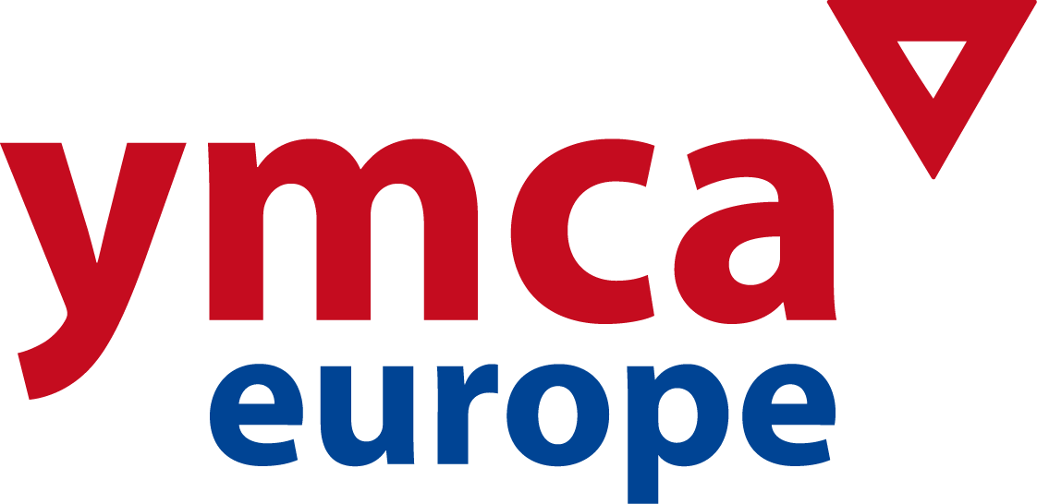

5th NATIONAL GENERAL SECRETARIES FORUM
Setubal, Portugal. October 3-5 2016

REGISTRATION FORM
Please return before SEPTEMBER 15th to:
eva@ymcaeurope.com

NAME: ___________________________________________________

NATIONAL YMCA _____________________________________________________
MAILING ADDRESS: _____________________________________________________
MOBILE PHONE: _______________________________________________________
E-mail: _______________________________________________________

TRAVEL DETAILS

Date / time of arrival: __________ / __________ Flight-no.: ___________
Date / time of departure: __________ / __________ Flight-no.: ___________

(FORUM STARTS OCT. 3RD AT LUNCH / CLOSING OCT. 5TH AT LUNCH)

ACCOMMODATION and MEALS
www.gruppoloan.it
- The following costs will be covered to all NGS´s attending: accommodation for the nights of October 3rd and 4th, meals from lunch Oct. 3rd until lunch Oct. 5th and all activities during the Forum.
- Accommodation at hotel before/after mentioned dates will not be covered in any case
- Single rooms have an extra cost of 20 € per night (breakfast included). Please indicate below if you prefer a single room.

TRANSPORTATION

- NGS´s will be responsible for the transportation costs to Setubal (Lisbon international airport)
A limited fund for travel costs will available and will be administrated by YMCA Europe´s Secretariat.

REMARKS (vegetarian, single/double room, etc): _____________________________

CONTRIBUTIONS
I would like to contribute with the amount of _____________ euros to help a NGS colleague covering the travel and visa costs.
DATE: __________________

