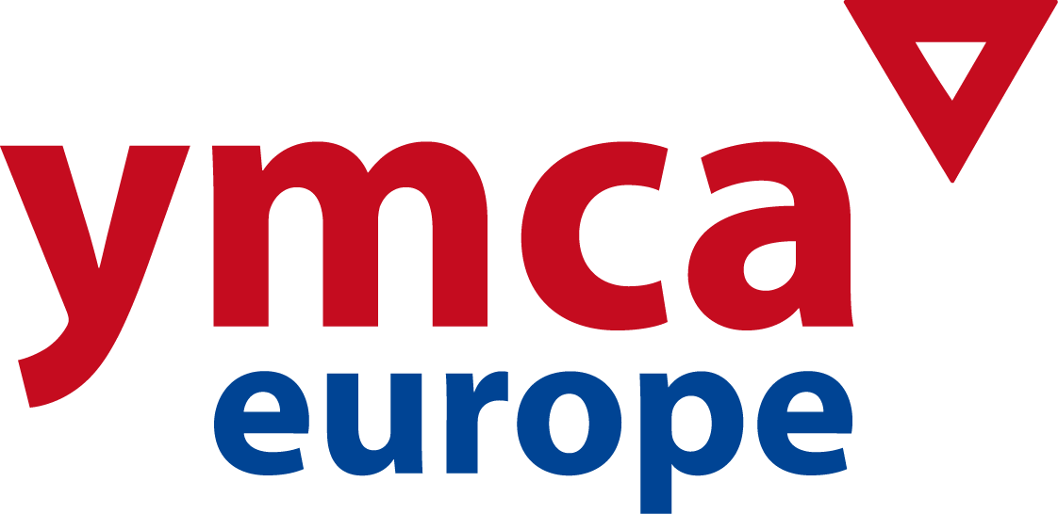

4th NATIONAL GENERAL SECRETARIES FORUM
Rome, Italy, November 23rd – 26th 2015

REGISTRATION FORM
Please return before October 1st to:
eva@ymcaeurope.com

NAME: ___________________________________________________

NATIONAL YMCA _____________________________________________________
MAILING ADDRESS: _____________________________________________________
MOBILE PHONE: _______________________________________________________
E-mail: _______________________________________________________

TRAVEL DETAILS

Date / time of arrival: __________ / __________ Flight-no.: ___________
Date / time of departure: __________ / __________ Flight-no.: ___________

(FORUM STARTS NOV. 23rd LUNCH / CLOSING NOV. 25th NOON AFTER VISIT TO VATICAN CITY)

ACCOMMODATION and MEALS

- Hotel Cristoforo Colombo (www.gruppoloan.it) and YMCA Sport Centre www.gruppoloan.it
- The following costs will be covered to all NGS´s attending: accommodation for the nights of Nov. 23rd, 24th and 25th, meals from lunch Nov. 23rd until breakfast Nov. 25th. Transportation hotel to/from Vatican City on Nov 25th
- Accommodation at hotel before/after mentioned dates will not be covered in any case
- Single rooms have an extra cost of 25 € per night (breakfast included). Please indicate below if you prefer a single room.
- Please do not make direct reservations at hotel.

TRANSPORTATION

- NGS´s will be responsible for the transportation costs to Rome
A limited fund for travel costs will available and will be administrated by YMCA Europe´s Secretariat.

REMARKS (vegetarian, single/double room, etc): _____________________________

CONTRIBUTIONS
I would like to contribute with the amount of _____________ euros to help a NGS colleague covering the travel and visa costs.
DATE: __________________

