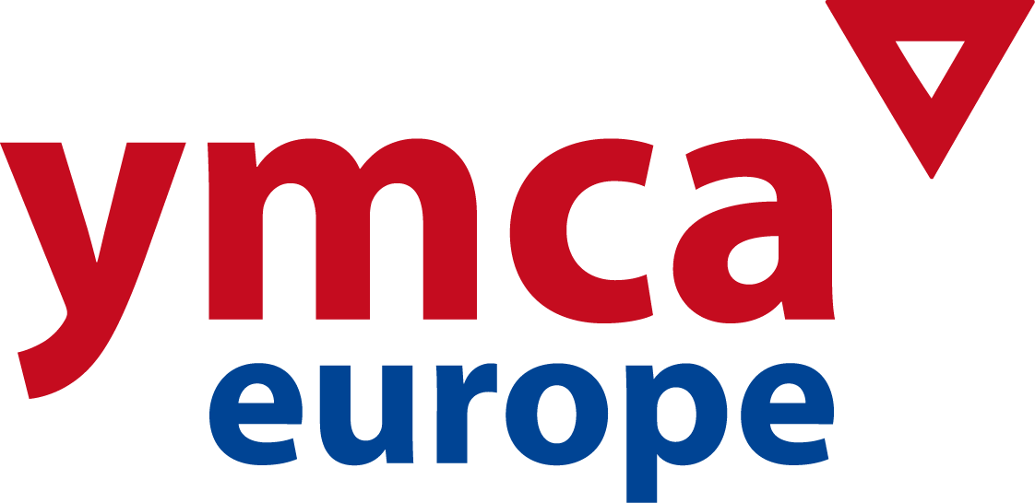

3rd FUNDRAISING CONFERENCE
Brussels, Belgium. January 23 – 25, 2014

REGISTRATION FORM
Please return at your earliest convenience to:
eva@ymcaeurope.com

NAME: ___________________________________________________

NATIONAL / LOCAL YMCA _______________________________________________________

MAILING ADDRESS: _______________________________________________________
MOBILE PHONE: _______________________________________________________

E-mail : _______________________________________________________

TRAVEL DETAILS

Date / time of arrival: __________ / __________ Flight-no.: ___________

Date / time of departure: __________ / __________ Flight-no.: ___________

(THE SEMINAR STARTS JAN 23rd AT LUNCH – FINISHES JAN 25th AFTER LUNCH)

ACCOMMODATION & FEES

- SINGLE ROOM. 315 euros (includes : single room accommodation, all meals during the Conference, materials)
- DOUBLE ROOM. 230 euros (includes : accommodation in double room, all meals during the Conference, materials)

REMARKS (single/double room, vegetarian, etc): _____________________________

DATE: __________________

